Reflective Practice: Decision-Making and Problem-Solving
Introduction
This reflection examines two separate experiences: my decision to establish my own business and my later problem of managing divorce, housing, finances, parenting and university study. For each, I first describe what I actually did without hindsight or module theory. I then “rewind” the scenario, apply critical-thinking methods, compare approaches and evaluate whether the module-informed approach would have produced a better decision or solution.
Case 1: The Decision to Start My Own Business
What I actually did at the time
Before starting my own business, I had worked for a company running weight-loss classes for approximately ten years. I was confident in the work and knew I was good at supporting clients. However, the company kept 40% of everything I earned. I began questioning whether continuing in the same arrangement made sense when I had the experience to work independently. I therefore started considering what I would need to do to make self-employment possible rather than simply deciding to leave immediately.
I had three young children. I needed an income but did not want childcare costs, so working for myself seemed to offer greater flexibility and the possibility of retaining more of my earnings. At the same time, I had never run a business and was frightened of failing. Therefore, I decided not to take that risk immediately. Instead, I took a full-time bank job for nine months and saved the income so I did not risk family finances. While working at the bank, I found premises, advertised my services and began building a client base. This allowed me to prepare the business before giving up my regular employment. After completing the nine months at the bank, I left on a Friday. During that time, I had built a client base of more than 40 people, which meant that when I started working for myself the following Monday, I already had clients booked. This helped make the transition into self-employment smoother and reduced the risk of losing income.
Rewinding the decision using module knowledge
Halpern's multiprocess model presents decision making as recursive: the decision is identified, alternatives are generated, costs and benefits considered, uncertainty evaluated, an option selected and the process reviewed (Halpern, 2014). My first module-informed change would therefore be to reframe the question. Instead of 'Should I leave secure employment and risk a business?', I would ask, 'How can I increase financial independence and flexibility while protecting family financial security?' Framing matters because it influences the alternatives generated and their evaluation (Halpern, 2014).
Figure 1
Module-informed decision pathway
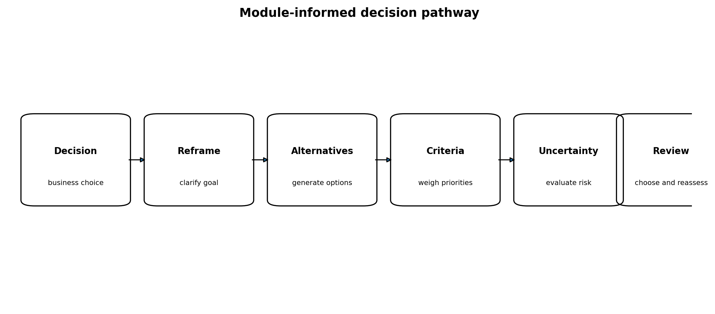
I would then use a decision worksheet. Following Halpern (2014), I would weight important criteria and rate each alternative, calculating: importance x rating = weighted value.

Table 1
Retrospective decision worksheet calculation
Criterion | Weight | Stay with company | Bank job + prepare business | Immediate self-employment
Financial security | 25 | 5 (125) | 5 (125) | 1 (25)
Income potential | 20 | 2 (40) | 3 (60) | 5 (100)
Flexibility | 20 | 2 (40) | 4 (80) | 5 (100)
Family compatibility | 15 | 3 (45) | 4 (60) | 5 (75)
Independence | 10 | 1 (10) | 3 (30) | 5 (50)
Risk reduction / preparation | 10 | 4 (40) | 5 (50) | 1 (10)
Total weighted score |  | 300 | 405 | 360

The calculation suggests that taking the bank job while preparing the business produced the strongest balance across my priorities. These ratings are retrospective illustrations, not data recorded at the time; their value is methodological because they make implicit assumptions and priorities explicit. This reflects Halpern’s concept of subjective utility, because the “best” option depends partly on personal values (Halpern, 2014).
Figure 2
Applying expected utility and Bayesian reasoning
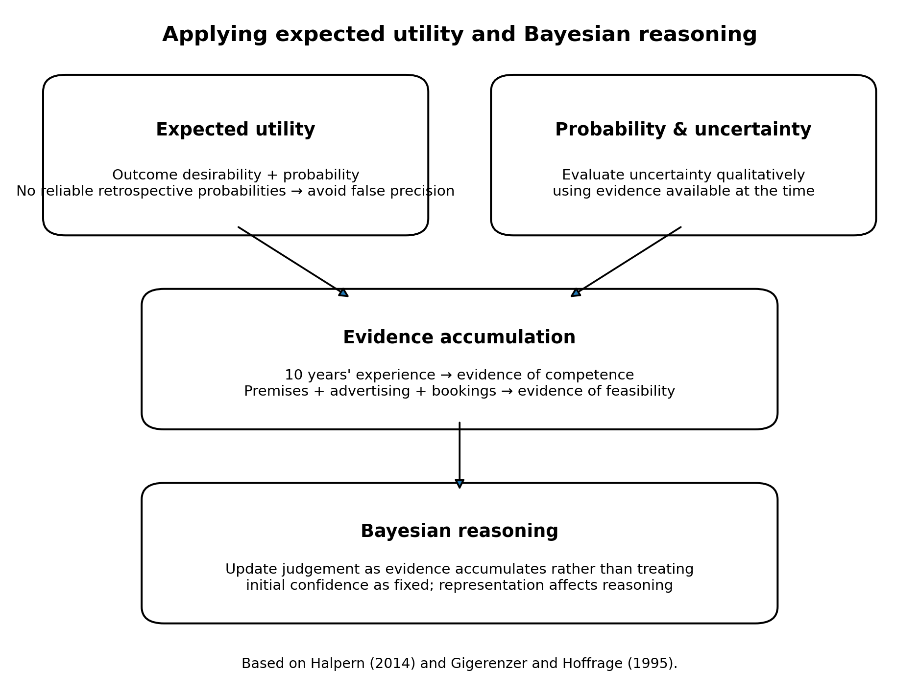
Note. Numerical probabilities are not assigned retrospectively because the necessary data were unavailable; uncertainty is therefore represented qualitatively. Based on Halpern (2014) and Gigerenzer and Hoffrage (1995).
Prospect theory also highlights how the same decision can be experienced differently when framed as gains or losses (Kahneman & Tversky, 1979). Potential gains included independence, greater control of income and flexibility; potential losses included secure employment and financial certainty. Considering both frames could help reveal whether the evaluation was being driven disproportionately by anticipated gains or losses. My fear of failure was therefore relevant to my perception of risk, but not evidence of the actual probability of failure.
I would test for confirmation bias by seeking evidence that contradicted my preferred option, such as likely client numbers, operating costs and competition (Nickerson, 1998). The Dunning-Kruger effect was also a potential risk because competence in delivering weight-loss classes did not guarantee competence in running a business (Kruger & Dunning, 1999). However, I recognised that limit: I knew I had never run a business and created a financial buffer before committing. This makes conscious risk management a more convincing explanation than Dunning-Kruger overconfidence.
Research showing that critical-thinking instruction can improve complex decision-making supports this structured approach (Helsdingen et al., 2010). It adds alternative generation, calculation, probability checking, reframing and bias testing.
Comparison and evaluation
My naïve approach relied on experience and intuition, but it was not irrational. My implicit argument was that I was experienced enough to deliver the service and could improve my financial and family situation through independence. The weakest assumption was that competence in the service would transfer automatically to business success. The module-informed approach would have exposed that assumption and required evidence beyond professional experience.
The worksheet favours the strategy I actually used: temporary employment combined with business preparation. This suggests module knowledge might have improved the transparency of my reasoning more than changed the final choice. It would also reduce hindsight bias because decisions should be judged using what was known at the time (Halpern, 2014).
Case 2: Solving the Problem of Divorce, Housing, Finances and University
What I actually did at the time
I had decided to complete a university degree when months later I went through a divorce. The family home sale fell through several times. The situation at home was not healthy for my children, so I needed to find suitable rented accommodation for myself and my three children.
At the same time, I was running my business, caring for my children and studying. My finances were insufficient to cover everything and pay the rent, so I also took a part-time bar job. Initially, I tried to manage everything simultaneously, but eventually it became too much. I realised my children had to be my priority, but I did not want to give up my degree. I contacted the university, explained my circumstances, and was allowed to take a temporary break and return once my housing and finances were more stable.
Rewinding the problem using module knowledge
Halpern (2014) describes a problem as a gap between a current state and a desired state. My situation was ill-defined because several goals and constraints interacted rather than one clear problem having one answer. I would therefore begin by representing the problem explicitly.
Figure 3
Module-informed problem representation
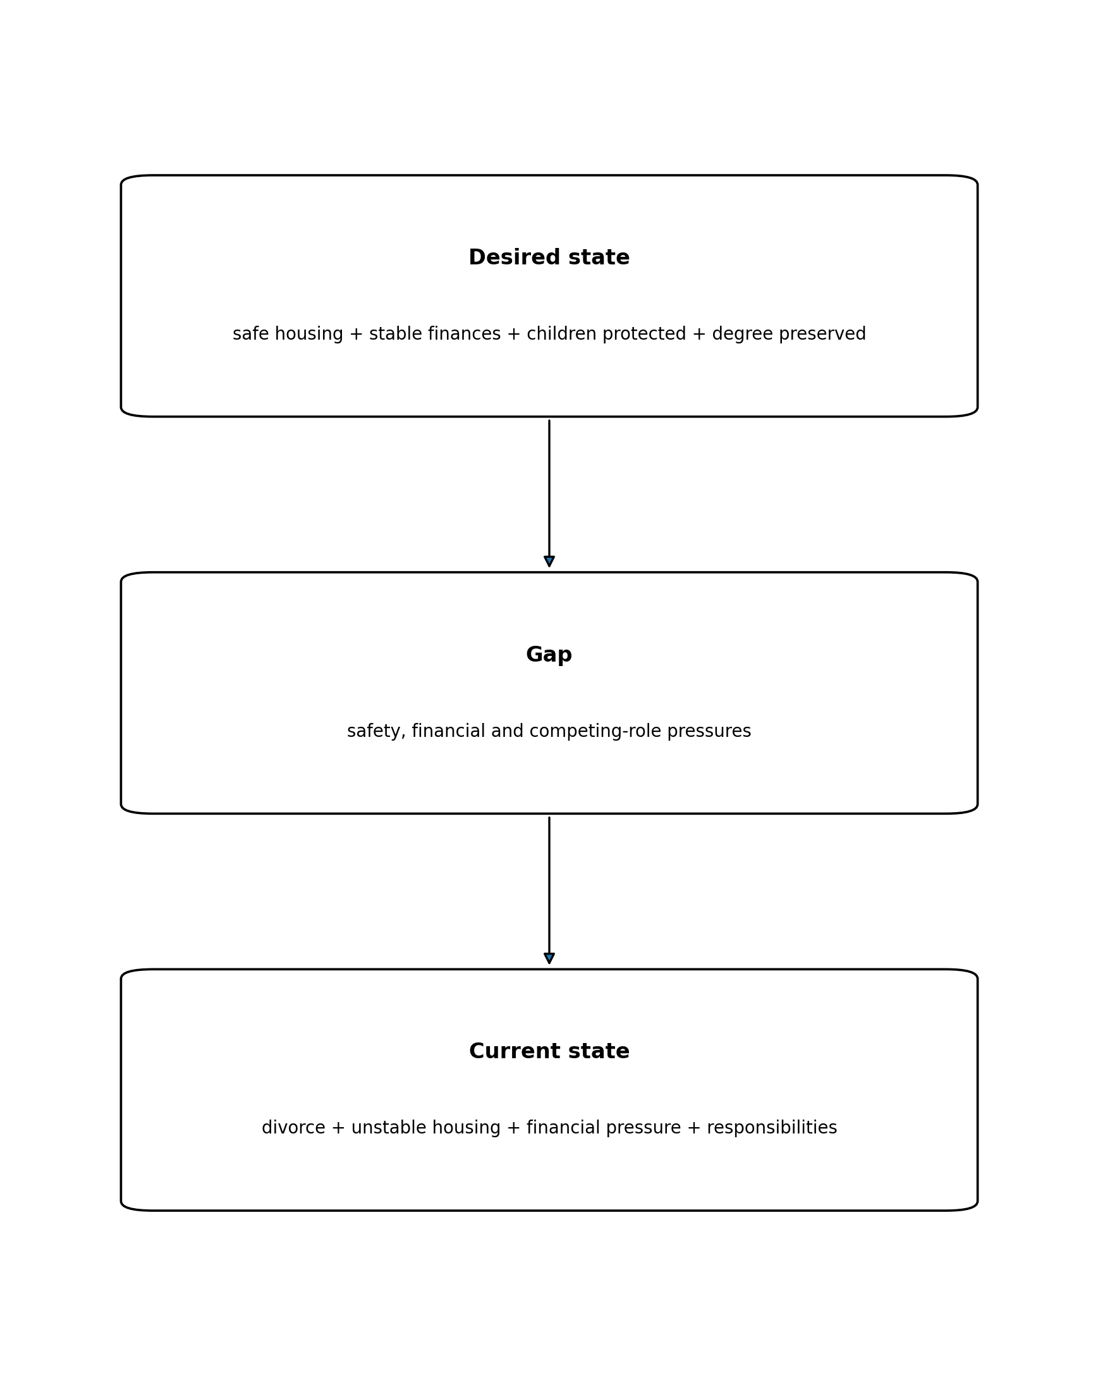
The givens and constraints included three children, an unhealthy home environment, repeated failed house sales, limited finances, business responsibilities and university study. Representing these separately would challenge my original assumption that everything had to continue simultaneously. Halpern (2014) argues that representation can reveal important relationships and broaden solution paths.
I would then use means-ends analysis: identify the differences between the current and desired states, create subgoals and choose operations that reduce those differences (Halpern, 2014).
Figure 4
Means–ends analysis
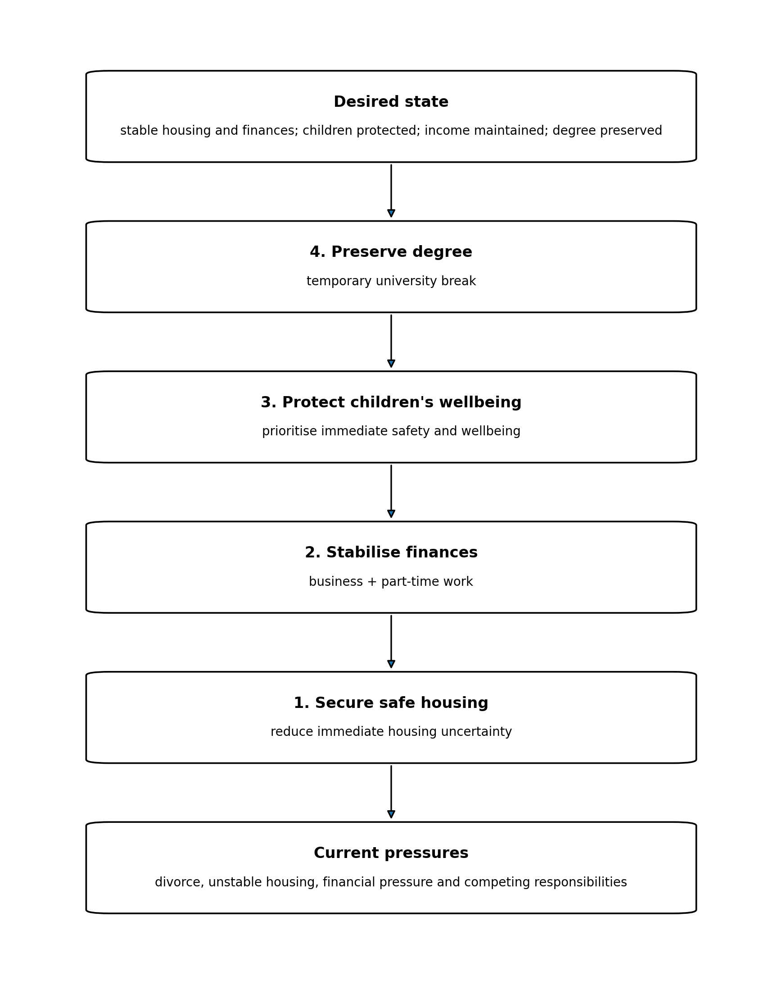
This changes the meaning of the university break. In the naïve representation, pausing study could appear to mean failure. In the module-informed representation, it is a temporary subgoal that reduces immediate pressure while preserving a longer-term goal. Contacting the university also generated a new solution path. The process was therefore recursive: when the initial strategy of maintaining everything simultaneously proved unsustainable, the problem could be reframed and the solution path changed.
The emotional dimension also matters. A purely rational representation might prioritise financial efficiency, whereas my children’s wellbeing needed greater weight. Critical thinking does not remove personal values; it makes them explicit so they influence problem solving deliberately.
Comparison and evaluation
My naïve approach attempted to solve everything simultaneously and only changed strategy once this became unsustainable. The module-informed approach would have separated immediate needs from long-term goals, represented constraints, generated subgoals and reviewed the strategy earlier. It may therefore have reached the same solution—temporarily pausing university—with less pressure and greater clarity. However, the framework cannot fully capture the emotional and changing nature of divorce. It is a structure for thinking, not a complete description of the experience.
Conclusion
These scenarios show that critical-thinking knowledge may improve a process without changing its outcome. In the business decision, weighted calculation, reframing, probability evaluation and bias checking would make my reasoning more explicit and testable while respecting personal values and uncertainty. In the problem scenario, problem representation and means-ends analysis clarify why pausing university was adaptive rather than abandoning the goal. The main difference is therefore between intuitive action and a more explicit, evidence-based and reviewable process.

References
Gigerenzer, G., & Hoffrage, U. (1995). How to improve Bayesian reasoning without instruction: Frequency formats. Psychological Review, 102(4), 684–704. https://doi.org/10.1037/0033-295X.102.4.684
Halpern, D. F. (2014). Thought and knowledge: An introduction to critical thinking (5th ed.). Psychology Press.
Helsdingen, A. S., van den Bosch, K., van Gog, T., & van Merriënboer, J. J. G. (2010). The effects of critical thinking instruction on training complex decision making. Human Factors, 52(4), 537–545. https://doi.org/10.1177/0018720810377069
Kahneman, D., & Tversky, A. (1979). Prospect theory: An analysis of decision under risk. Econometrica, 47(2), 263–292. https://doi.org/10.2307/1914185
Kruger, J., & Dunning, D. (1999). Unskilled and unaware of it: How difficulties in recognizing one's own incompetence lead to inflated self-assessments. Journal of Personality and Social Psychology, 77(6), 1121–1134. https://doi.org/10.1037/0022-3514.77.6.1121
Nickerson, R. S. (1998). Confirmation bias: A ubiquitous phenomenon in many guises. Review of General Psychology, 2(2), 175–220. https://doi.org/10.1037/1089-2680.2.2.175

